Press Contact:
FOR IMMEDIATE RELEASE
Yvonne Yang, VP of Business Development
Homestead High School FBLA
Phone Number: (408) 663-0104
Email: vpbizdev@hhsfbla.com

Homestead FBLA Ends the Year with Success
at the 2016 National Leadership Conference in Atlanta

Cupertino, California – Homestead High School Future Business Leaders of America (FBLA) continued to excel and succeed at the National Leadership Conference in Atlanta, Georgia. The annual National Leadership Conference was held on June 29 to July 2 and students from all over the nation gathered to compete in business-related events. Students displayed knowledge and professionalism in fields such as business management and technology. Out of the 96 Homestead students competing, 56 students placed in 26 events and there were national champions in 4 events. Homestead earned 187 points, the most out of all the schools in the nation. With over 9,300 competitors at the National Leadership Conference, Homestead members had the excellent opportunity to Connect with members from other states and attend workshops to develop business knowledge and leadership skills.

Homestead FBLA President Naomi Jung expresses that she is “extremely proud of all of the dedicated members and was excited to see their hard work culminate at this year's National Leadership Conference. Homestead FBLA once again proved its competitive prowess, but more importantly, members demonstrated their positive sportsmanship and steadfast support for one another.”

Homestead FBLA expresses gratitude to all the advisers, mentors, and officers who dedicated their time and effort toward helping Homestead competitors prepare for the conference. Special thanks to: advisers Helen Carlson, Byron Lee, and Graeme Logie; mentors Rita Allen, Bruce Levin, Visish Srinivasan, Esther Heller, Laurie Iwami, Jane Babicz, Christy Heaton, Braden Holstege, Nancy Liao, Aria Srinivasan, Mark Sagherian, Rich Knapp, Edmond Kwong, Hilary Lai, Gene Longinetti, Rob Bertolina, and John Shelby; the competitions officers Heidi Dong, Edward Li, Shaunak Modak, Soham Pardeshi, Rie Ohta; proctor Amity Bateman; and chaperones William Lee and Maya Bronicki.
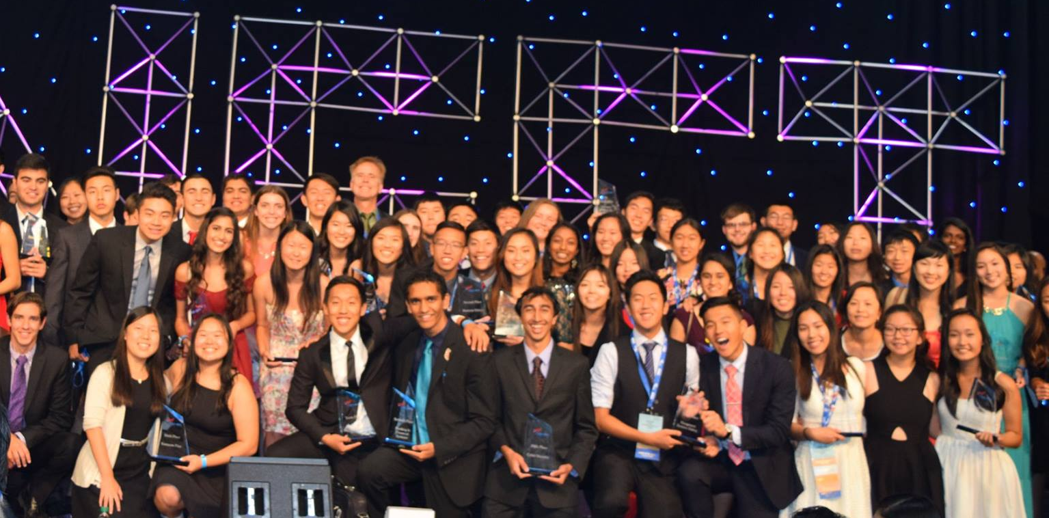
Homestead FBLA after the Awards Ceremony at the National Leadership Conference.
The following is a list of Homestead’s placing:

3D ANIMATION  2nd Place – Avani Modak, Primo Mu,  Rithika Srinivasan  ACCOUNTING 2  7th Place – Claire Li  BANKING AND FINANCIAL SYSTEMS  7th Place – Emily Cai, Rie Ohta, Shaunak Modak  BUSINESS CALCULATIONS  1st Place – Michael Chen  BUSINESS COMMUNICATIONS  3rd Place – Maggie Wu  BUSINESS ETHICS  2nd Place – Rebecca Cockroft, Erin Liu, Japheth K. Yeung  BUSINESS LAW  1st Place – Helen Rhee  2nd Place – Christine Yu  8th Place – Annabelle Chan  BUSINESS PLAN  6th Place – Sabina Anand, Hannah Goh  COMMUNITY SERVICE PROJECT  5th Place – Anisha Chandra, Grace Kim, Helen Rhee  COMPUTER APPLICATIONS  10th Place – Jeff Yang  CYBER SECURITY  5th Place – Soham Pardeshi  DATABASE DESIGN & APPLICATION  9th Place – Justin Wen  ECONOMICS  6th Place – Nadav Bronicki  7th Place – Joshua Zhou  ENTREPRENEURSHIP  1st Place – Jonathan Mendelson, Cyrus Miremadi, Austin Song | GLOBAL BUSINESS  7th Place – Naomi Jung, Josh Shamelashvili, Odette Wang  HELP DESK  10th Place – Sandy Pan  HOSPITALITY MANAGEMENT  2nd Place – Jacob Jiao, Yannik Omictin, Aditya Sampath  INTRODUCTION TO BUSINESS  3rd Place – Sohum Oza  INTRODUCTION TO BUSINESS PRESENTATION  10th Place – Valerie Hu, Mita Ramesh, Kathy Tien  INTRODUCTION TO BUSINESS PROCEDURES  1st Place – Emily Gao  INTRODUCTION TO FINANCIAL MATH  2nd Place – Rebecca Zhu  INTRODUCTION TO PARLIAMENTARY PROCEDURE  7th Place – Shannon Cheung  LOCAL CHAPTER ANNUAL BUSINESS REPORT  2nd Place – Ryan Hironaka, Naomi Jung, Adela Yang  MANAGEMENT DECISION MAKING  10th Place – Brandon Chen, Edward Li, Venkata Muriki  MANAGEMENT INFORMATION SYSTEMS  9th Place – Anne He, Leo Yao, Bobby Zhang  MARKETING  3rd Place – Danielle Collett, Ryan Hironaka, Peggy Xu  PARLIAMENTARY PROCEDURE  2nd Place – Brandon Hong, Seohyun Park, Ninad Swadi, Yvonne Yang, Alina Zeng  SOCIAL MEDIA CAMPAIGN  4th Place – June Moon, Lindsey Rosenthal, Kelly Xu

